|  |
| --- |
| D’Arcy Mcgee High school |
| Final Written Exam Review Package |
| MUS 402/502-01: Grade 10/11 Music |
|  |
| **Ms. Rigden** |
| **5/1/2016** |

**Section 1: Note Reading**

**Treble Clef- Identify the following notes:**

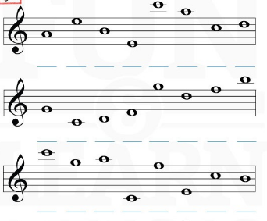

**Bass Clef- Identify the following notes:**

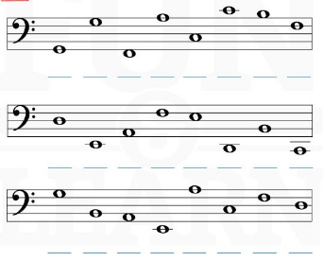

**Section 2: Reading and counting rhythms**

**Match the LETTER on the left to the note/rhythm on the right.**

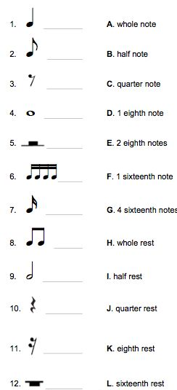

**Write the correct counting under the following rhythmic examples. **Each bar = 4 beats\*\***

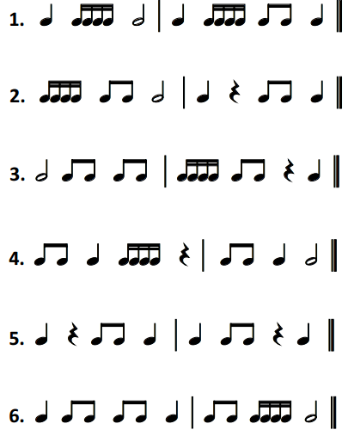

**Section 3: Stylistic and Expressive elements**

**Name and define the following dynamic markings:**



= ____________ meaning to play ______________

= ____________ meaning to play ______________

= ____________ meaning to play ______________

= ____________ meaning to play ______________

= ____________ meaning to play ______________

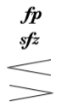= ____________ meaning to play ______________

= ____________ meaning to _____________________________

= ____________ meaning to ____________________________

= ____________ meaning to ____________________________

= ____________ meaning to ____________________________

**Section 4: Jazz Music**

**Ragtime**

1. Dates: 1880s-early 1900s
2. **True/False questions:** Describe at least 3 MUSICAL characteristics/facts (Ragtime Music)
   1. One of the earliest musical styles that contributed to jazz
   2. Syncopated (off the beat) style of music
   3. Composed primarily for the piano/banjo
   4. Music from the plantations of America’s south
3. **Short Answer questions:** Scott Joplin – Explain facts regarding his life, work and contributions to ragtime jazz music
   1. Studied the piano
   2. Born in Texas
   3. African-American—he did not attend school because of this
   4. Wrote appox. 50 piano rags
   5. Played piano in bars to help support himself
   6. The Entertainer, Maple Leaf Rag

**Blues**

1. Dates: 1900-1920s
2. **True/False questions:** Describe at least 3 MUSICAL characteristics/facts (Blues Music)
   1. Predominantly vocal traditions
   2. Important influence on the development of jazz
   3. Stories of African-Americans during the early 1900s
   4. Blues melody—distinct style using blues notes instead of simple major scales
   5. Accompanied vocalists with guitar, banjo, piano—sometimes trumpet/saxophone
3. **Name 4 famous musicians** popular during the blues time period
   1. Bessie Smith
   2. Ma Rainey
   3. W.C. Handy
   4. Pa Rainey

**Dixieland**

1. Dates: 1917-1920s
2. **True/False questions:** Describe at least 3 MUSICAL characteristics/facts (Dixieland early jazz)
   1. Transition period into Big Band Music
   2. Started involving brass instruments
   3. “New Orleans Jazz”
   4. Music is characterized by upbeat tempos, 4/4 meter, and triplet rhythms
   5. Developed following WW1
   6. Familiar melodies heard everyday (musicians play from memory) with a blue styles
3. **Short Answer Questions :** Louis Armstrong—Explain facts regarding his life, style of music and major contributions to jazz
   1. Trumpet player / vocalist
   2. Popularized scat singing—using “nonsense” words
   3. Prominent Band Leader
   4. Solo improvisation
   5. Distinct gravelly voice which helped with scatting

**Big Band Music** (4 Periods: Early, Big Band Boom and Postwar to Present)

1. Dates:
   1. Early Period: 1920s
   2. Big Band Boom: 1930-1940s
   3. Postwar Period: 1940-50s
   4. Present Period: 1950s to PRESENT
2. **True/False questions:** Describe at least 5 MUSICAL characteristics/facts (at least 1 for each time period)
   1. **EARLY:**
      1. SWING—easy to dance to
      2. Main melody performed by entire ensemble, followed by jazz improv solos, then back to main melody
      3. Relied more on saxes and brass (trumpet/trombone) & rhythm section
   2. **BIG BAND BOOM:**
      1. Continuation of the early period style—POPULAR!
      2. Radio and in big ballrooms
   3. **POSTWAR:**
      1. Decline in big band music
      2. Started to use new styles—bebop, cool jazz, pop and rock styles
   4. **PRESENT:**
      1. BEBOP!
      2. Small groups of musicians- 4 to 6 people
      3. Solo opportunity
      4. Unsuitable for dancing—irregular rhythms/phrases
3. **Fill in the blanks questions with musicians’ names:** Big Band Boom – Historical facts regarding the following musicians: Count Basie, Woody Herman, Benny Goodman
   1. Woody Herman:
      1. Born 1913-1987
      2. Herman’s Herd or Swinging Herd- Herman was the band leader
   2. Benny Goodman:
      1. Clarinet player, very virtuosic (improv solos)
      2. Band leader
4. **Fill in the blanks questions with musicians’ names:** Postwar Period — facts regarding the following musicians: Stan Kenton, Mel Lewis, Thad Jones
   1. Stan Kenton:
      1. Loudest Big Bands—because of a BIG brass section
      2. Composition over improv—a lot more music written down
      3. Helped to develop modern jazz education programs
   2. Mel Lewis:
      1. Formed and co-led big band with Thad Jones
      2. Drummer
   3. Thad Jones:
      1. Cornetist/Flugelhorn player
      2. Self-taught musician
      3. Toured and recorded professionally by 16 years old

**Section 5: Canadian Music**

Choose ONE Canadian Musician or Band: Write a ½ page biography of this artist or band.

* Include elements such as:
  + 1. Date and place of birth
    2. Education
    3. Solo career information AND/OR Band information
    4. Major achievements/ Lifetime accomplishments
    5. Musical success or failures
    6. An overview of what makes the person/band significant in the music industry

____________________________________________________________________________________________________________________________________________________________________________________________________________________________________________________________________________________________________________________________________________________________________________________________________________________________________________________________________________________________________________________________________________________________

______________________________________________________________________________________________________________________________________________________________________________________________________________________________________________________________________________

______________________________________________________________________________________________________________________________________________________________________________________________________________________________________________________________________________

______________________________________________________________________________________________________________________________________________________________________________________________________________________________________________________________________________

______________________________________________________________________________________________________________________________________________________________________________________________________________________________________________________________________________